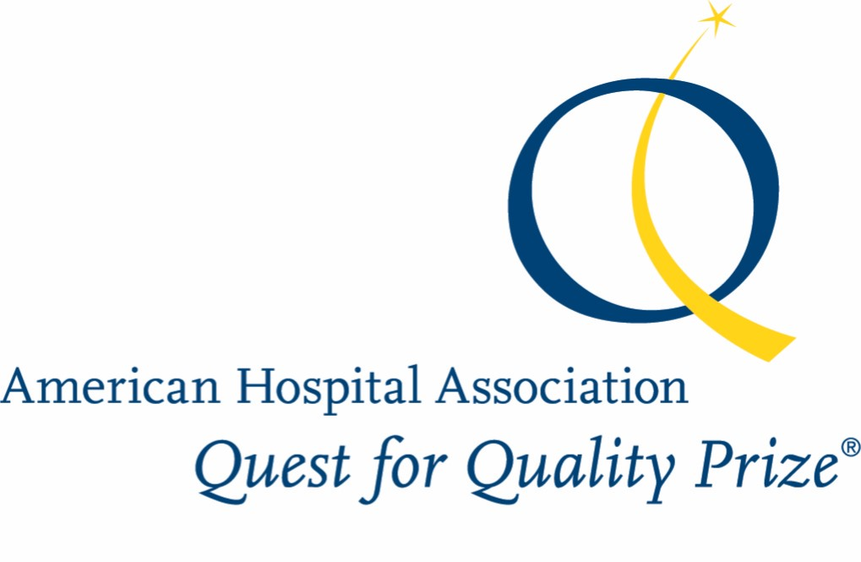

The American Hospital Association Quest for Quality Prize®
2020 Hospital Application

The American Hospital Association Quest for Quality Prize® is presented annually to recognize health care leadership and innovation in improving quality and advancing health in communities. Prize honors are: one winner; up to two finalists; and up to four Citation of Merit honorees; no more than five honors will be awarded. The goals of this award are to:
- raise awareness of the value of a hospital-wide/system-wide commitment to advancing health in America by providing access to exceptional quality, safe and patient- and family-centered care that promotes individual and community well-being
- showcase successful efforts to develop and promote new models of care, services and collaboration
- inspire hospitals and systems to lead and partner with other community organizations to improve health status
- recognize hospital and system leadership to improve quality, safety, and community health status

In 2020, the prize will honor hospitals and systems striving to achieve the American Hospital Association’s five commitments to:
- Access: Access to affordable, equitable health, behavioral and social services
- Health: Focus on holistic well-being in partnership with community resources
- Innovation: Seamless care propelled by teams, technology, innovation and data
- Affordability: The best care that adds value to lives
- Individual as Partner: Recognize the diversity of individuals and serve as partners in their health

The AHA Quest for Quality Prize is generously sponsored by RL Solutions, AHA’s Champion Sponsor for Quality.

The 2020 prize will be presented at the 2020 AHA Leadership Summit (July 25-27) in San Diego.

Eligibility
All hospitals and health systems in the United States are eligible to apply for the award. Please note that the hospital application is different from the health system application and be sure you are using the appropriate application. Please be aware that a hospital that is part of a system may apply separately using the hospital application even if the system as a whole is applying using the system application. However, if the system is selected for a site visit, the hospital would not be eligible for a separate site visit and would be considered only as part of the system.

Application Materials
This applications can also be downloaded directly from www.aha.org/questforquality. If you have questions about the award, please contact the AHA Office of the Secretary, 312-422-2700 or e-mail questforquality@aha.org.

Each application has four parts:
1. cover page signed by the CEO
2. completed demographics section
3. responses to specific questions on your systems to improve and ensure overall quality
4. up to seven pages for attachments and appendices

No supplemental materials in binders or special folders or video/audio materials will be accepted.

Requirements
Organizations selected for site visits will be asked to provide additional follow-up information for the AHA Quest for Quality Prize Committee. They also will be expected to identify a cross-section of key leaders willing to work with AHA and the selection committee to teach others about their strategies to improve the quality of care. Honorees will be expected to participate as requested in outreach and education, including public speaking engagements at various forums and working with editors and writers of AHA and its subsidiaries and other publications as requested by the American Hospital Association.

All applications become the property of the American Hospital Association and may be used in AHA’s activities to provide “best practices” and examples of different approaches to achieving AHA’s five commitments. In these cases, AHA will contact the hospital to explore its interest in participating in an interview or case study. All materials submitted for site visits will be kept confidential.

Evaluation and Judging
The applications are reviewed by members of the AHA Quest for Quality Committee. The Committee selects organizations to be site visited, participates in site visits, and decides which honors are to be presented. During the site visits, the Committee members will be particularly interested in seeing evidence of trends in improvement and impact on patients and the community. The site visitors will be interested in hearing what steps have been taken to ensure that process changes have led to the desired improvements in outcomes and to sustain performance improvements. The Committee is looking for an organization-wide commitment to and participation in improved quality and safety, innovations to improve care, addressing disparities, and working with other community organizations and agencies to improve health status. The Committee also will want an understanding of the replicability of successful practices and policies.

The American Hospital Association Quest for Quality Prize® is administered by the Health Research & Educational Trust. AHA is grateful for the extensive volunteer contributions made by Committee members.

Submission of Applications
Completed applications may be either uploaded (preferred) or mailed. Uploaded applications must be submitted by midnight Central Time, Monday, Sept. 30, 2019, to https://ahaconnect.org/quest_for_quality_upload.php. We strongly encourage you to convert your application and attachments/appendices into a single pdf file to ensure that all materials are seen by the Committee and to minimize the chance of possible distortion in graphs, charts and layout. The file name should contain the name of your organization.

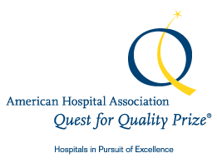

The American Hospital Association Quest for Quality Prize®
2020 Application for Hospitals

Hospital Name: ______________________________________________________

Application Contact: ____________________________________________________

Title of Contact: ____________________________________________________

Street Address: ____________________________________________________

City, State, Zip Code: ____________________________________________________

E-mail Address: ____________________________________________________

Phone Number: ____________________________Fax :_____________________

The following should be read and signed by the hospital CEO.

The AHA Quest for Quality Prize seeks to increase understanding of the value of organizational focus and commitment to achieving quality health care and advancing health in communities. Hospitals and systems are urged to consider participation in the awards process both as a recognition and an assessment of their efforts to meet the AHA Path Forward’s five commitments of access, health, innovation, affordability, individual as partner. All applications for the AHA Quest for Quality Prize® become the property of the American Hospital Association. Descriptions of the honored programs will be published, and the Association may use information from all applications in articles aimed at increasing awareness and ability of organizations to implement a system-wide commitment to quality and patient safety improvement. Program contacts may be asked to provide additional information. I agree, if our system is being considered for recognition, to host a site visit as part of the final selection process. I also understand that the honorees will be expected to participate in outreach, sharing of organizational improvement efforts and knowledge.

I certify that the information in this application is accurate.

Signature _____________________________________________________Date__________

Title________________________________________________________________________
Guidelines/Guidance for Completing this Application:
- A team approach to completing this application is recommended. This team may include patients/family members. In general, applications that are written by staff with primary responsibility for quality improvement (rather than public relations, marketing or grant writers) in close collaboration with senior leadership are more likely to include the type of information the committee is seeking.
- Given that reviewers read many applications, please be sure your application is easy to read and uses 12-point type, lets some white space show on the page, and has been proofread. Be sure that the charts or tables included in attachments/appendixes are easy to read and photocopy legibly.
- If a system or mechanism that you have already described as a response to one question is also relevant to another answer, please feel free to refer to the original description and explanation rather than repeat it.
- Part II of the application seeks a better understanding of how your hospital is approaching and progressing on these basic hospital commitments. To the extent possible, please emphasize integration of AHA’s five commitments and systemic approaches across and throughout the hospital.
- Please note that the word limits in Part II are maximums, not suggestions; the prize committee appreciates concise and direct responses; bulleted responses rather than narrative text is allowed, but please be sure that a context for understanding the bullets is provided. Concrete examples with pertinent details to substantiate broad statements provide greater understandability and credibility for your application. Charts and tables should be included in attachments or appendixes. Be sure to relate data to specific care improvement efforts and processes. Data on progress should be as recent as possible and include relevant benchmarking data. Please do not exceed more than seven (7) pages of attachments/appendixes/etc.
- The committee also will be examining publicly available indicators such as hospital performance on the Hospital Compare website (www.hospitalcompare.hhs.gov) and reliable sources of comparative data.

Part I: ORGANIZATIONAL Demographic Information

1a) Number of acute care beds currently set up and staffed for use in your hospitals (please check one):

_________ Fewer than 100 beds

_________ 100 to 299 beds

_________ 300 to 499 beds

_________ 500 beds and over

1b) Other types of facilities owned and operated by the hospital (ambulatory clinics, physician offices, surgicenters, long-term care facilities, etc.):

________________________________________________________________

________________________________________________________________

1c) Annual number of outpatient visits in these facilities: _________

1d) Part of a System _________ Independent _________

2) Type of hospital (please check one):

_________ State or local government

_________ Academic medical center

_________ Non-government, not-for-profit

_________ Investor-owned, for-profit

_________ Military

_________ Veterans’ Affairs

_________ US Public Health Service

_________ Other: _________________________________________

3) Financial information on your hospital:

Net operating margin (percent) ________________%

Bond rating ________________

Days cash on hand ________________

4a) If you have PHYSICIAN residency training programs approved by the Accreditation Council for Graduate Medical Education, how many FTE residents do you employ in each type of residency

________________________________________________________________

________________________________________________________________

________________________________________________________________

________________________________________________________________

4b) Please list other types of training programs in your hospital (i.e., nursing, pharmacy, social work, physical therapy, etc.):

________________________________________________________________

________________________________________________________________

________________________________________________________________

________________________________________________________________

5) Location of your hospital (please check one):

_________ Urban

_________ Suburban

_________ Rural

6) What percentage of physicians on staff at the hospital are:

_________ % Employed by the hospital

_________ % In a physician group associated with the hospital

7) What is the size of your:

_________ Governing board

_________ Medical staff

_________ Executive staff

_________ Employed staff (other than employed physicians included in medical staff count above)
_________ Volunteer organization

8) Please indicate percentages for each of the following categories. Racial/ethnic percentages must add up to 100%.

 | Female | Caucasian | Latino/ Hispanic | African/ American | Asian | Other
Hospital governing board
Hospital executive staff
Medical staff
Employees other than medical staff
Volunteers

Community

9) What is your annual rate of staff turnover? ___________________

SERVICE Demographic Information

- Scope of service area (check one):
_________ Portion of community
_________ Entire community
_________ Community and surrounding area
_________ Multiple communities
2a) Patient language demographics:
_________% English as primary language
_________% Non-native English speaker
_________% Little or no English (requiring interpreter)
2b) Languages most frequently spoken by non-native English speakers (no more than
top 5):
__________________________________________________________

3) Patient insurance demographics:

_________% Private insurance
_________% Medicare
_________% Medicaid or other public assistance only
_________% Medicare/Medicaid (other public assistance) dual eligible
_________% No coverage

Part II: Quest for Quality Domains
The Quest for Quality Prize honors hospitals and systems that are committed to and are making demonstrable progress toward making AHA’s vision of a society of healthy communities where all individuals reach their highest potential for health a reality. The foundation of this vision is the five commitments defined below. As you answer the following sections, consider how some or all of these commitments are integrated into your work:
- Access: Access to affordable, equitable health, behavioral and social services
- Health: Focus on holistic well-being in partnership with community resources
- Innovation: Seamless care propelled by teams, technology, innovation and data
- Affordability: The best care that adds value to lives
- Individual as Partner: Recognize the diversity of individuals and serve as partners in their health

A. LEADERSHIP (1,200 words maximum)
Please describe:

- How the governing board participates in establishing and supporting quality goals and the five commitments.

- How the hospital leadership and governing board hold themselves accountable to the community for the hospital’s initiatives to improve access, value, partnership, wellbeing and coordination.

- How your senior leadership ensures that the desired culture and leadership style is diffused throughout your organization and how it engages the employees, medical staff, patients and families in the planning processes, goal setting, progress evaluation and change implementation.

- How senior leaders and the governing board assess culture, leadership style and employee, medical staff, patient and family engagement and how often these issues are reviewed and discussed.

- How leadership prioritizes quality and safety initiatives, sets goals and monitors progress toward safer, accessible health care.

- Efforts and progress made toward increasing diversity among hospital leadership, governance, medical staff, employees and volunteers to reflect the ethnic/racial makeup of the community.

B. QUALITY AND SAFETY TO IMPROVE VALUE (1,400 words maximum)
Please describe and attach data to show results:

- A successful quality improvement initiative, including how your organization identified the practice/process change and, if applicable, ensured its systematic application throughout the hospital. Please provide data that supports this success.

- How your organization empowers physicians, front-line caregivers and other staff to actively participate in and lead process change and quality improvement efforts, and discuss how this expectation is reinforced, evaluated and recognized.

- How the hospital addresses near misses and adverse events, including how they are reported and shared throughout the hospital, and how decisions regarding corrective actions are made and disseminated.

- Hospital policies and procedures on how patients and families are informed of errors, the processes in place to keep them informed as an investigation progresses, and how this is monitored.

- How the hospital promotes a just culture for patients and families as well as staff.

- How your hospital uses data and analytics to support coordination of care across all settings.

- How clinical guidelines and care protocols are used to ensure that the right care is delivered at the right time.

C. PARTNERING WITH PATIENTS AND FAMILIES (1,000 words maximum)
Please describe:

- How patients and families are involved in designing the total experience of care, including efforts to meet special physical, psychological, developmental, cultural and spiritual needs.

- How patient and family advisors are involved and supported as members of patient and family advisory councils and members of safety and quality improvement teams.

- How your hospital enhances patient access to useful information, including a patient’s own medical record as well as information about patient educational resources, while protecting confidentiality.

- How your hospital gathers patient feedback and how that information is used. If possible, provide a specific example of an instance when patient feedback led to a process change.

- How your organization partners with patients, families, and community members to help them improve and maintain their health.

D. WORKFORCE (1,000 words maximum)
Please describe:

- How employees and clinical staff are trained in and promote the five commitments of access, value, partnership, wellbeing and coordination, and how the organization evaluates the effectiveness of the training.

- How your organization assesses physician and employee satisfaction and engagement, how often that assessment occurs, and examples of how that information is used.

- How the methods and frequency of how your hospital assesses employee and medical staff perceptions of the quality and safety culture within your organization, and how personal accountability plays a role in the quality and safety culture.

E. COMMUNITY (1,000 words maximum)
Please describe:

- How the hospital selects the community stakeholders (employers, schools, police, religious organizations, agencies, etc.) with which it partners to identify and address specific community health needs.

- How the hospital is partnering with community agencies and organizations to achieve the AHA’s five commitments of access, value, partnership, wellbeing and coordination. Share examples of how your organization is working with others to expand access to address the unmet needs of your community, support patients after discharge, and address social determinants of health. Describe the initiatives and the results.

- How your hospital identifies and takes action to address the community’s racial, ethnic and gender disparities in health as well as medical care.

- How the hospital measures and demonstrates accountability for improving community health status and outcomes. Please provide supporting data.

- How your organization demonstrates transparency with the community, including reporting clinical performance measures.
F. INNOVATION (800 words maximum)
Please describe:

- How the hospital creates a culture and atmosphere that welcomes and values innovative ideas from all staff members, regardless of job title.

2. What your hospital considers its most significant, unique and creative innovation and its related outcomes. Include measurable data showing progress and address other organizations’ ability to replicate these innovations.

3. How your hospital has adapted and implemented the innovations of other organizations.

